$$∑=G(m_{1}*l_{1}+m_{2}*(l_{1}+l_{2}){+m}_{3}*(l_{1}+l_{2}+l_{3}))$$

This is representation of the arm extended to it furthest reach in the x axis.

$$l_{1}$$

$$l_{3}$$

$$m_{3}$$

$$m_{2}$$

$$m_{1}$$

$$l_{2}$$

This diagram below represents how the arm will move in space. Theta(cos of theta) will oonly be need when NOT at 90 degrees.

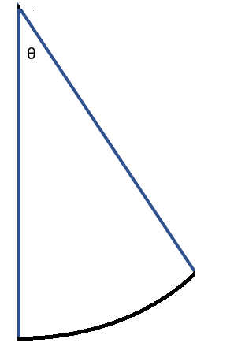

Where the Red arrow represents the length in out equation and the and the Yellow arrow represents the arm itself. The purple arrow doesn’t mean much for the moment as the joint supporting that is a z axis stepper motor.

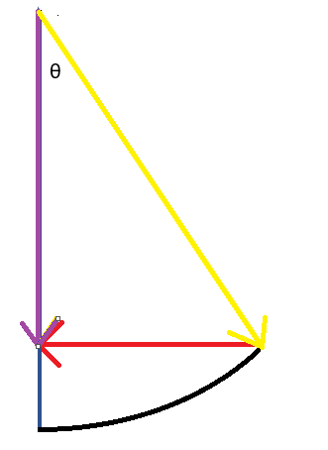

We can sum them like this, we can break this down as many times as we like to get a more accurate mass ratio across the arm. For this example I have only chosen 3 to represent how the equations work.

